- Copyright for test papers and marking guides remains with West Australian Test Papers.
- The papers may only be reproduced within the purchasing school according to the advertised conditions of sale.
- Test papers must be withdrawn after use and stored securely in the school until 14th June.

PHYSICS
UNIT 3
2024

MARKING GUIDE

TIME ALLOWED FOR THIS PAPER

Reading time before commencing work: Ten minutes
Working time for the paper: Three hours

MATERIALS REQUIRED/RECOMMENDED FOR THIS PAPER

To be provided by the supervisor:
- This Question/Answer Booklet; Formula and Constants sheet

To be provided by the candidate:
- Standard items: pens, pencils, eraser or correction fluid, ruler, highlighter.

- Special items: Calculators satisfying the conditions set by the SCSA for this subject.

IMPORTANT NOTE TO CANDIDATES
No other items may be taken into the examination room. It is your responsibility to ensure that you do not have any unauthorised notes or other items of a non-personal nature in the examination room. If you have any unauthorised material with you, hand it to the supervisor before reading any further.

Structure of this paper

Section | Number of questions available | Number of questions to be answered | Suggested working time  (minutes) | Marks available | Percentage of exam
Section One:  Short answer | 11 | 11 | 50 | 54 | 30
Section Two:  Extended answer | 7 | 7 | 90 | 90 | 50
Section Three:  Comprehension  and data analysis | 2 | 2 | 40 | 36 | 20
 |  |  | Total | 180 | 100

Instructions to candidates

- The rules for the conduct of Western Australian external examinations are detailed in the Year 12 Information Handbook 2024. Sitting this examination implies that you agree to abide by these rules.

- Write your answers in this Question/Answer Booklet.

- When calculating numerical answers, show your working or reasoning clearly. Give final answers to three (3) significant figures and include appropriate units where applicable.

When estimating numerical answers, show your working or reasoning clearly. Give final answers to a maximum of two (2) significant figures and include appropriate units where applicable.

- You must be careful to confine your responses to the specific questions asked and follow any instructions that are specific to a particular question.

- Spare pages are included at the end of this booklet. They can be used for planning your responses and/or as additional space if required to continue an answer.
  - Planning: If you use the spare pages for planning, indicate this clearly.
  - Continuing an answer: If you need to use the space to continue an answer, indicate in the original answer space where the answer is continued, i.e. give the page number. Refer to the question(s) where you are continuing your work.

Question 1 (4 marks)

Which quantity below is DIFFERENT for shots A and B? Circle your response.
Briefly explain why your chosen quantity is correct and why the others are not.

Element | Description | Marks
Chooses correct answer | Initial Velocity | 1
Refers to time of flight | Since the max heights are equal, the time of flight of A and B are equal ($t_{A}=t_{B}$).  OR  Since the vertical velocities of A and B are equal, the time of flight of A and B are equal ($t_{A}=t_{B}$). | 1
Refers to horizontal velocities | As the horizontal range is doubled, the horizontal velocity of shot B must be double the horizontal velocity of shot A (since the time is same).  $$u_{x,B}=2 u_{x,A}$$ | 1
Refers to initial velocity | Hence, since the horizontal component of initial velocity of B is double A and the vertical components are the same, the initial velocity will be different. | 1
 | Total | 4

Question 2 (7 marks)

(a) In the diagram below draw a free body diagram of all the forces acting on the milk bottle as it slides down the shelf. (3 marks)

Description | Marks
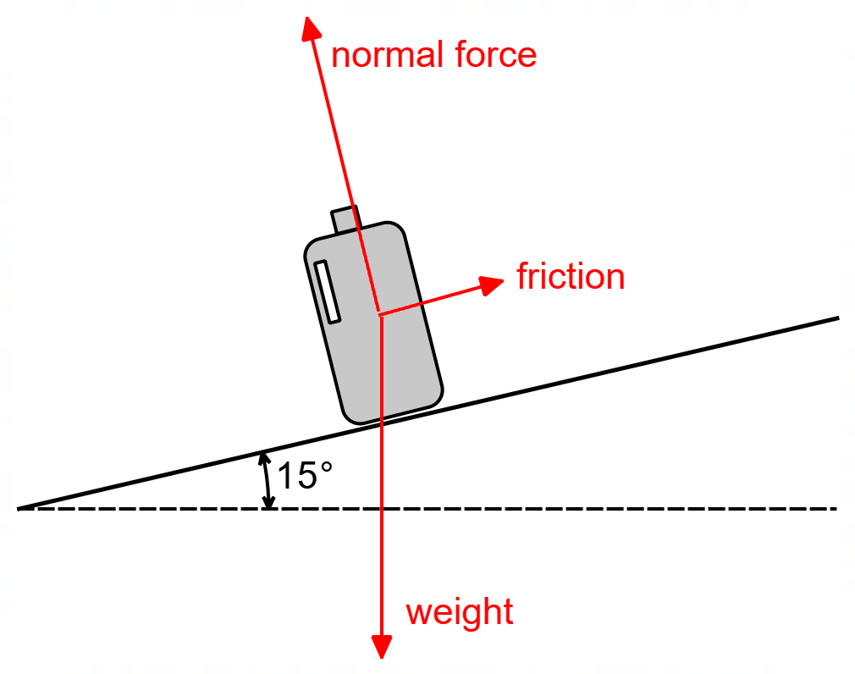
Free Body diagram includes three forces (weight, normal and friction) | 1
Normal force drawn perpendicular to surface | 1
Friction force $F_{f}$ is directed up the slope | 1
Total | 3

(b) As a bottle slides down the shelf, the frictional force between the shelf and the bottle is about 25% of the normal force acting on the bottle. Estimate the friction force acting on a milk bottle as it slides down the shelf, giving your answer to an appropriate number of significant figures.
(4 marks)

Element | Description | Marks
Assumes the mass of 2L milk (& bottle) is approx. 2 kg and calculates weight force | $$W=mg=2×9.8=19.6 N$$ | 1
Calculates the normal force | $$N=W\cos{θ}$$  $$N=19.6×\cos{15}$$  $$N=18.9 N$$ | 1
Calculates friction force | $$F_{f}=0.25×18.9=4.73 N$$ | 1
To max 2 SF | $$F_{f}=4.7 N$$ | 1
 | Total | 4

Question 3 (4 marks)

(a) As the vehicle moves, an EMF is induced across the length of the aerial. Which end of the aerial becomes positively charged (circle your answer)? (1 mark)

Element | Description | Marks
Correct end | TOP | 1
 | Total | 1

(b) Calculate the EMF induced across the length of aerial, in millivolts (mV). (3 marks)

Element | Description | Marks
Uses formula for EMF | $$ε=vBL$$ | 1
Uses correct velocity (converting to $m/s$), correct B field (using $\cos{20.0°}$) and correct length. | $$ε=\left(30.0\right)(5.30×{10}^{-5}×\cos{20.0°)}(1.22)$$ | 1
Calculates correct EMF | $$ε=1.82 mV$$ | 1
 | Total | 3

Question 4 (4 marks)

How long does it take for the component to reach the surface of the moon?

Element | Description | Marks
Converts vertical velocity to $m/s$, uses gravitational acceleration for moon, and adopts a sign convention | $$u=72/3.6=20 m/s$$  $$g=-1.62 m/s^{2}$$  $$s=-370 m$$ | 1
Uses equation of motion to find time | $$s=ut+\frac{1}{2}at^{2}$$  $$-370=20t+0.5×(-1.62)t^{2}$$ | 1
Calculates time using quadratic formula | $$0=-0.81t^{2}+20t+370$$  $$t=\frac{-20±\sqrt{{20}^{2}-4(-0.81)(370)}}{2(-0.81)}$$ | 1
Solves for times, ignores negative | $$t=-12.3, t=37.0$$  $$t=37.0 s$$ | 1
 | Total | 4

Question 5 (5 marks)

Calculate the tension in Chain 2.

Element | Description | Marks
Calculates distance from pivot to centre of Rod A, $d_{A}$ | $$d_{A}=1.50/2-\left(1.50-1.25\right)$$  $$d_{A}=0.75-0.25=0.50 m$$ | 1
Calculates distance from pivot to centre of Rod B, $d_{B}$ | $$d_{B}=2.00/2-\left(2.00-1.40-0.40\right)$$  $$d_{B}=1.00-0.20=0.80 m$$ | 1
Sums torques about end of chain 1 and writes CW and ACW torques (or $Στ=0$) | $$τ_{CW}=W_{B}.d_{B}$$  $$τ_{ACW}=W_{A}.d_{A}+T_{2}×1.40$$ | 1
Uses the correct weights of Rod A and Rod B and uses the calculated distances of $d_{A}$ and $d_{B}$ | $$\left(2.00×9.8\right)×0.50+T_{2}×1.40=(6.00×9.8)×0.80$$  $$9.8+T_{2}×1.40=47.04$$ | 1
Calculates tension in chain 2 | $$T_{2}=26.6 N$$ | 1
 | Total | 5

Question 6 (6 marks)

(a) Calculate the centripetal force required for this person to travel in a circular path, as Mars rotates on its axis. (3 marks)

Element | Description | Marks
Calculates velocity $v$  OR  Substitutes velocity formula into $F_{c}$ formula | $$v=\frac{2πr}{T}=\frac{2π×3.39×{10}^{6}}{24.7×60×60}=239.5 m/s$$  OR  $$F_{c}=\frac{mv^{2}}{r}=\frac{m{\left(\frac{2πr}{T}\right)}^{2}}{r}=\frac{4mπ^{2}r}{T^{2}}$$ | 1
Calculates $F_{c}$ using velocity, mass, and radius.  OR  Calculates $F_{c}$ using mass, radius, and period. | $$F_{c}=\frac{75.0×{239.5}^{2}}{3.39×{10}^{6}}$$  OR  $$F_{c}=\frac{4mπ^{2}r}{T^{2}}=\frac{4(75.0)π^{2}(3.39×{10}^{6})}{{(24.7×60×60)}^{2}}$$ | 1
Calculates centripetal force | $$F_{c}=1.27 N$$ | 1
 | Total | 3

(b) If this person was standing stationary at the equator on the surface of Earth, would the centripetal force required be greater or smaller than on Mars? Explain using relevant formula and data from your Formula & Data Booklet (no calculation is needed). (3 marks)

Element | Description | Marks
Uses correct data of radius and period for Earth and Mars and compares radii and rotational period. | $$r_{E}=6370 km, r_{M}=3390 km$$  $$T_{E}=24.0 hrs, T_{M}=24.7 hrs$$  $$r_{E}≈2×r_{M}$$  $$T_{E}≈T_{M}$$ | 1
Compares velocities and radii of Earth and Mars. | $$F_{c}=\frac{mv^{2}}{r} and v=\frac{2πr}{T}$$  $$∴v_{E}≈2×v_{M}$$  $$→v_{E}^{2}≈4×v_{M}^{2}$$ | 1
Compares $F_{c}$ on Earth and Mars. Concludes correctly. | $$Since F_{cE}≈2×F_{cM}$$  $$∴Greater$$ | 1
 | Total | 3

Question 7 (5 marks)

(a) Determine the direction of the current flowing in the circular copper coil as the pendulum moves through the field at Position (1) and Position (2). Indicate the direction below either as Clockwise (CW), Anticlockwise (ACW) or None. (2 marks)

Element | Description | Marks
Correct direction at Position (1) | Anticlockwise (ACW) | 1
Correct direction at Position (2) | None | 1
 | Total | 2

(b) It is noticed that the pendulum comes to a stop after only a few oscillations, despite the pendulum being free to swing. Explain the sudden loss of kinetic energy with reference to relevant physics principles. (3 marks)

Element | Description | Marks
Correct application of Lenz’s Law | Lenz’s law states that the induced current will create a magnetic field that will oppose the motion of the coil. | 1
Describes the effect of the induced current on the coil | Hence the force on the coil, due to the induced current, will oppose the motion of the coil, slowing it as it enters and exits the field. | 1
Describes correct energy transformation from kinetic to heat energy. | The kinetic energy of the coil is transformed into electrical energy, then dissipated as heat energy via the electrical resistance in the coil. | 1
 | Total | 3

Question 8 (3 marks)

An AC generator produces 11.0 kW of power for a nearby mine site. The power is transmitted at 240 V along a 5.00 km transmission line, which has a total resistance of 0.150 Ω.

Calculate the voltage supplied to the mine site.

Element | Description | Marks
Calculates transmission current | $$P=V.I→I=\frac{P}{V}=\frac{11×{10}^{3}}{240}=45.83 A$$ | 1
Uses correct resistance, and calculates voltage drop | $$V=I.R=45.83×0.15=6.875 V$$ | 1
Calculates voltage delivered to mine site | $$V=240-6.875=233 V$$ | 1
 | Total | 3

Question 9 (4 marks)

A simple DC motor consists of 33 turns of wire, formed into a square coil of side length 6.00 cm, attached to a voltage source of 25.4 V. If the length of wire has a resistance of 3.42 Ω and the coil is placed in a uniform magnetic field of strength 1.06 T, calculate the maximum torque produced by the motor.

Element | Description | Marks
Calculates current in coil | $$I=\frac{V}{R}=\frac{25.4}{3.42}=7.43 A$$ | 1
Calculates force on 1 wire | $$F=BIL=1.06×7.43×0.06=0.472 N$$ | 1
Uses number of turns  Incorporates both sides of coil | $$τ=2×N×F.r$$  $$=2×33×0.472×\left(\frac{0.06}{2}\right)$$ | 1
Calculates correct torque | $$τ=0.935 Nm$$ | 1
 | Total | 4

Question 10 (5 marks)

(a) Calculate the strength of the electric field experienced by the electron, due to the presence of the alpha particle. (2 marks)

Element | Description | Marks
Uses the electric field strength equation, the force on electron and charge of electron | $$E_{a}=\frac{F_{e}}{q_{e}}=\frac{7.67×{10}^{-19}}{1.6×{10}^{-19}}$$ | 1
Calculates correct electric field | $$E_{a}=4.79 N/C$$ | 1
 | Total | 2

(b) Using the given data, show that the charge on the alpha particle is +2$e$.
(3 marks)

Element | Description | Marks
Uses Coulomb’s Law | $$F=\frac{1}{4πε_{0}}\frac{q_{a}.q_{e}}{r^{2}}→q_{a}=\frac{4πε_{0}.F.r^{2}}{q_{e}}$$ | 1
Substitutes correct values into equation for $ε_{0}$, $q_{e}$, $F$ and $r$. | $$q_{a}=$$  $$\frac{4π×8.85×{10}^{-12}×7.67×{10}^{-19}×{(0.0245×{10}^{-3})}^{2}}{1.6×{10}^{-19}}$$ | 1
Calculates correct electric charge of alpha and demonstrates that its $+2e$ | $$q_{a}=3.20×{10}^{-19} C=+2e$$ | 1
 | Total | 3

Question 11 (7 marks)

(a) In the diagram below (right), a car is travelling on a banked curve angled $θ$ to the horizontal. In the dashed box below (left), draw a labelled vector diagram of all the forces acting on the car (ignoring friction). Include the resultant force as a dotted/dashed line. (3 marks)

Element | Description | Marks
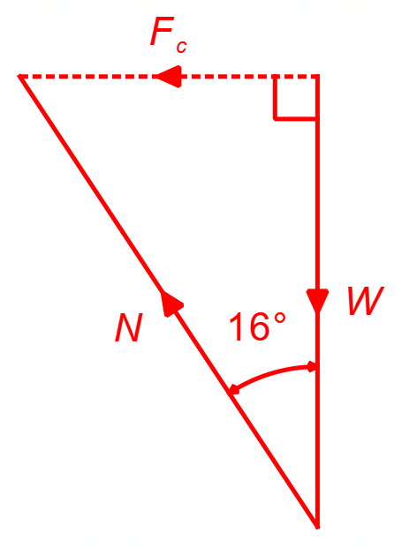
Weight and Normal force | $W$ and $N$ arranged head to tail and labelled correctly | 1 – 2
Resultant force | $F_{c}$ drawn horizontally and labelled correctly | 1
 | Total | 3

(b) Using your vector diagram above, show that the speed of the car $v$ is given by $v=\sqrt{rg\tan{θ}}$. Then, use this formula to calculate the speed of a car travelling around this banked curve, of radius 386 m, angle at 16.0° to the horizontal, while not relying on friction. (4 marks)

Element | Description | Marks
Uses trig to relate $F_{c}$ and $W$ force | $$\tan{θ}=\frac{F_{c}}{W}=\frac{\frac{mv^{2}}{r}}{mg}$$ | 1
Correctly rearranges for expression for velocity | $$v^{2}=rg\tan{θ}$$  $$v=\sqrt{rg\tan{θ}}$$ | 1
Substitutes values of radius and angle | $$v=\sqrt{386×9.8×\tan{16.0}}$$ | 1
Calculates correct speed | $$v=32.9 m/s$$ | 1
 | Total | 4

Question 12 (12 marks)

(a) Calculate the tension in the string as the ball travels horizontally to Bailey. (3 marks)

Element | Description | Marks
Relates tension $T$ to weight force $W$ | $$\cos{62.0°}=\frac{W}{T}$$  $$T=\frac{W}{\cos{62.0°}}$$ | 1
Substitutes values for weight mass to find tension force $T$ | $$T=\frac{0.150×9.8}{\cos{62.0°}}$$ | 1
Calculates correct tension force $T$ | $$T=3.13 N$$ | 1
 | Total | 3

(b) For the ball to be returned in a completely vertical circular path and complete a full circle without the string coming slack, it needs to have sufficient speed. Show that the minimum speed $v_{m}$ the ball must have at the top of the swing, for it to travel in a vertical circular path, is given by $v_{m}=\sqrt{rg}$. (3 marks)

Element | Description | Marks
Recognises that $a_{c}=g$ when string becomes slack. | At top, when slack:  $$F_{c}=W$$  $$∴a_{c}=g$$  (i.e., $N=0$) | 1
Uses centripetal acceleration formula | $$\frac{v_{m}^{2}}{r}=g$$ | 1
Correctly derives formula for critical speed $v_{m}$ | $$v_{m}=\sqrt{rg}$$ | 1
 | Total | 3

(c) When the ball arrives at Bailey, he hits the ball so that it has 6.00 J of kinetic energy as it starts downwards on its vertical circular path. Using this information and using an energy consideration, show that the ball is travelling at sufficient velocity to ensure the string doesn’t become slack. (6 marks)

Element | Description | Marks
Correctly calculates minimum velocity $v_{m}$ | $$v_{m}=\sqrt{1.80×9.8}=4.20 m/s$$ | 1
Calculates change in height $h$ of ball | $$h=r+L\cos{62.0°}$$  $$h=1.80+1.80×\cos{62.0°}=2.65 m$$ | 1
Equates total energy at top of swing to 6.00 J | $$E_{top}=mgh+\frac{1}{2}mv^{2}$$  $$E_{top}=mgh+\frac{1}{2}mv^{2}=6.00$$ | 1
Substitutes values into energy equation | $$6.00=\left(0.150×9.8×2.65\right)+\frac{1}{2}×0.150 v^{2}$$ | 1
Solves for velocity at top of swing | $$6.00=3.89+0.075v^{2}$$  $$v=5.31 m/s$$ | 1
Correct conclusion | Since $5.31>4.20$ the string will not become slack. | 1
 | Total | 6

Question 13 (9 marks)

(a) Calculate the peak voltage in the secondary coil of the transformer. (3 marks)

Element | Description | Marks
Uses turns ratio | $$\frac{N_{p}}{N_{s}}=\frac{V_{p}}{V_{s}}→\frac{400}{5600}=\frac{240}{V_{s}}$$ | 1
Calculates secondary RMS voltage | $$V_{s}=\frac{240×5600}{400}=3360 V$$ | 1
Converts to peak voltage | $$V_{peak}=V_{s}×\sqrt{2}=3360×\sqrt{2}=4.75×{10}^{3} V$$ | 1
 | Total | 3

(b) The voltage delivered to the primary coil oscillates at a frequency of 50.0 Hz and voltage generated in the secondary coil alternates at the same rate. With reference to Faraday’s Law, explain how a higher voltage is induced in the secondary coil by the primary coil.
(4 marks)

Description | Marks
Due to the alternating current in the primary coil, an alternating flux is created in the primary coil, at a rate of 50.0 Hz. | 1
This alternating flux is transmitted to the secondary coil at the same frequency. | 1
Faraday’s law indicates that the induced voltage in the second coil is proportional to the rate of change of flux and the number of turns of wire. | 1
Since rate of change of flux is the same, but the number of turns of wire in the secondary coil is higher, the voltage in the secondary coil will be higher. | 1
Total | 4

(c) State and explain one (1) source of inefficiency in a non-ideal transformer. (2 marks)

Element | Description | Marks
Source | Formation of Eddy currents in transformer core  OR  Heat loss in coils | 1
Explanation | The formation of eddy currents in transformer core dissipate energy as heat, resulting in power loss.  OR  The energy loss (in the form of heat) in the coils of a transformer caused by the resistance in the wire of the coils ($P_{loss}=I^{2}R$). | 1
 | Total | 2

Question 14 (7 marks)

(a) Account for the shape of the path of the proton in the magnetic field. (3 marks)

Element | Description | Marks
Magnetic force | Due to the presence of the magnetic field the proton (charged) experiences a force $F=qvB$ | 1
Refers to perpendicular | The force on the proton acts perpendicular to the velocity and field (according to RHP rule) | 1
Refers to circular motion | Since force is continually perpendicular to motion, the proton follows a circular path. | 1
 | Total | 3

(b) Calculate the magnitude of the force on the proton in the magnetic field. (2 marks)

Element | Description | Marks
Substitutes correct values into $F=qvB$ | $$F_{B}=qvB=1.60×{10}^{-19}×1.88×{10}^{6}×2.50×{10}^{-3}$$ | 1
Calculates correct magnetic force | $$F_{B}=7.52×{10}^{-16} N$$ | 1
 | Total | 2

(c) Calculate distance $d$. (2 marks)

Note: if you couldn’t calculate the force in part (b) you may use a force of 8.00 × 10^{–16} N.

Element | Description | Marks
Relates magnetic force for centripetal force and uses proton mass | $$F_{B}=\frac{mv^{2}}{r}$$  $$7.52×{10}^{-16}=\frac{1.67×{10}^{-27}×{\left(1.88×{10}^{6}\right)}^{2}}{\frac{1}{2}d}$$ | 1
Calculates correct value of $d$ | $$d=15.7 m (14.8 m)$$ | 1
 | Total | 2

Question 15 (16 marks)

(a) Using data from the first table, calculate the values of the two missing entries A and B in the second table. Show your complete working below. (4 marks)

Element | Description | Marks
Converts day to seconds | $$A=0.311×24×3600=26907 s$$ | 1
Squares to find $A$ | $$A=\frac{{26907}^{2}}{{10}^{8}}=7.24$$ | 1
Converts to meters | $$B=6.20×{10}^{4}×{10}^{3}=6.20×{10}^{7} m$$ | 1
Cubes to find $B$ | $$B=\frac{{\left(6.20×{10}^{7}\right)}^{3}}{{10}^{23}}=2.38$$ | 1
 | Total | 4

(b) On the set of axes on the next page construct a graph of $T^{2}$ (on the vertical axis) versus $r^{3}$ (on the horizontal axis). Indicate appropriate scales and axis labels and draw in a line of best fit for the data. (4 marks)

Element | Description | Marks
See graph on next page
Correctly plots period squared versus radius cubed | $T^{2}$ on vertical axis and $r^{3}$ on horizontal axis | 1
Accurate plotting | Coordinate points are all accurately plotted | 1
Scale and Labels | Axis scale and labels are included, including units and scale factors | 1
Line of best fit | A LOBF is accurately drawn through the data | 1
 | Total | 4

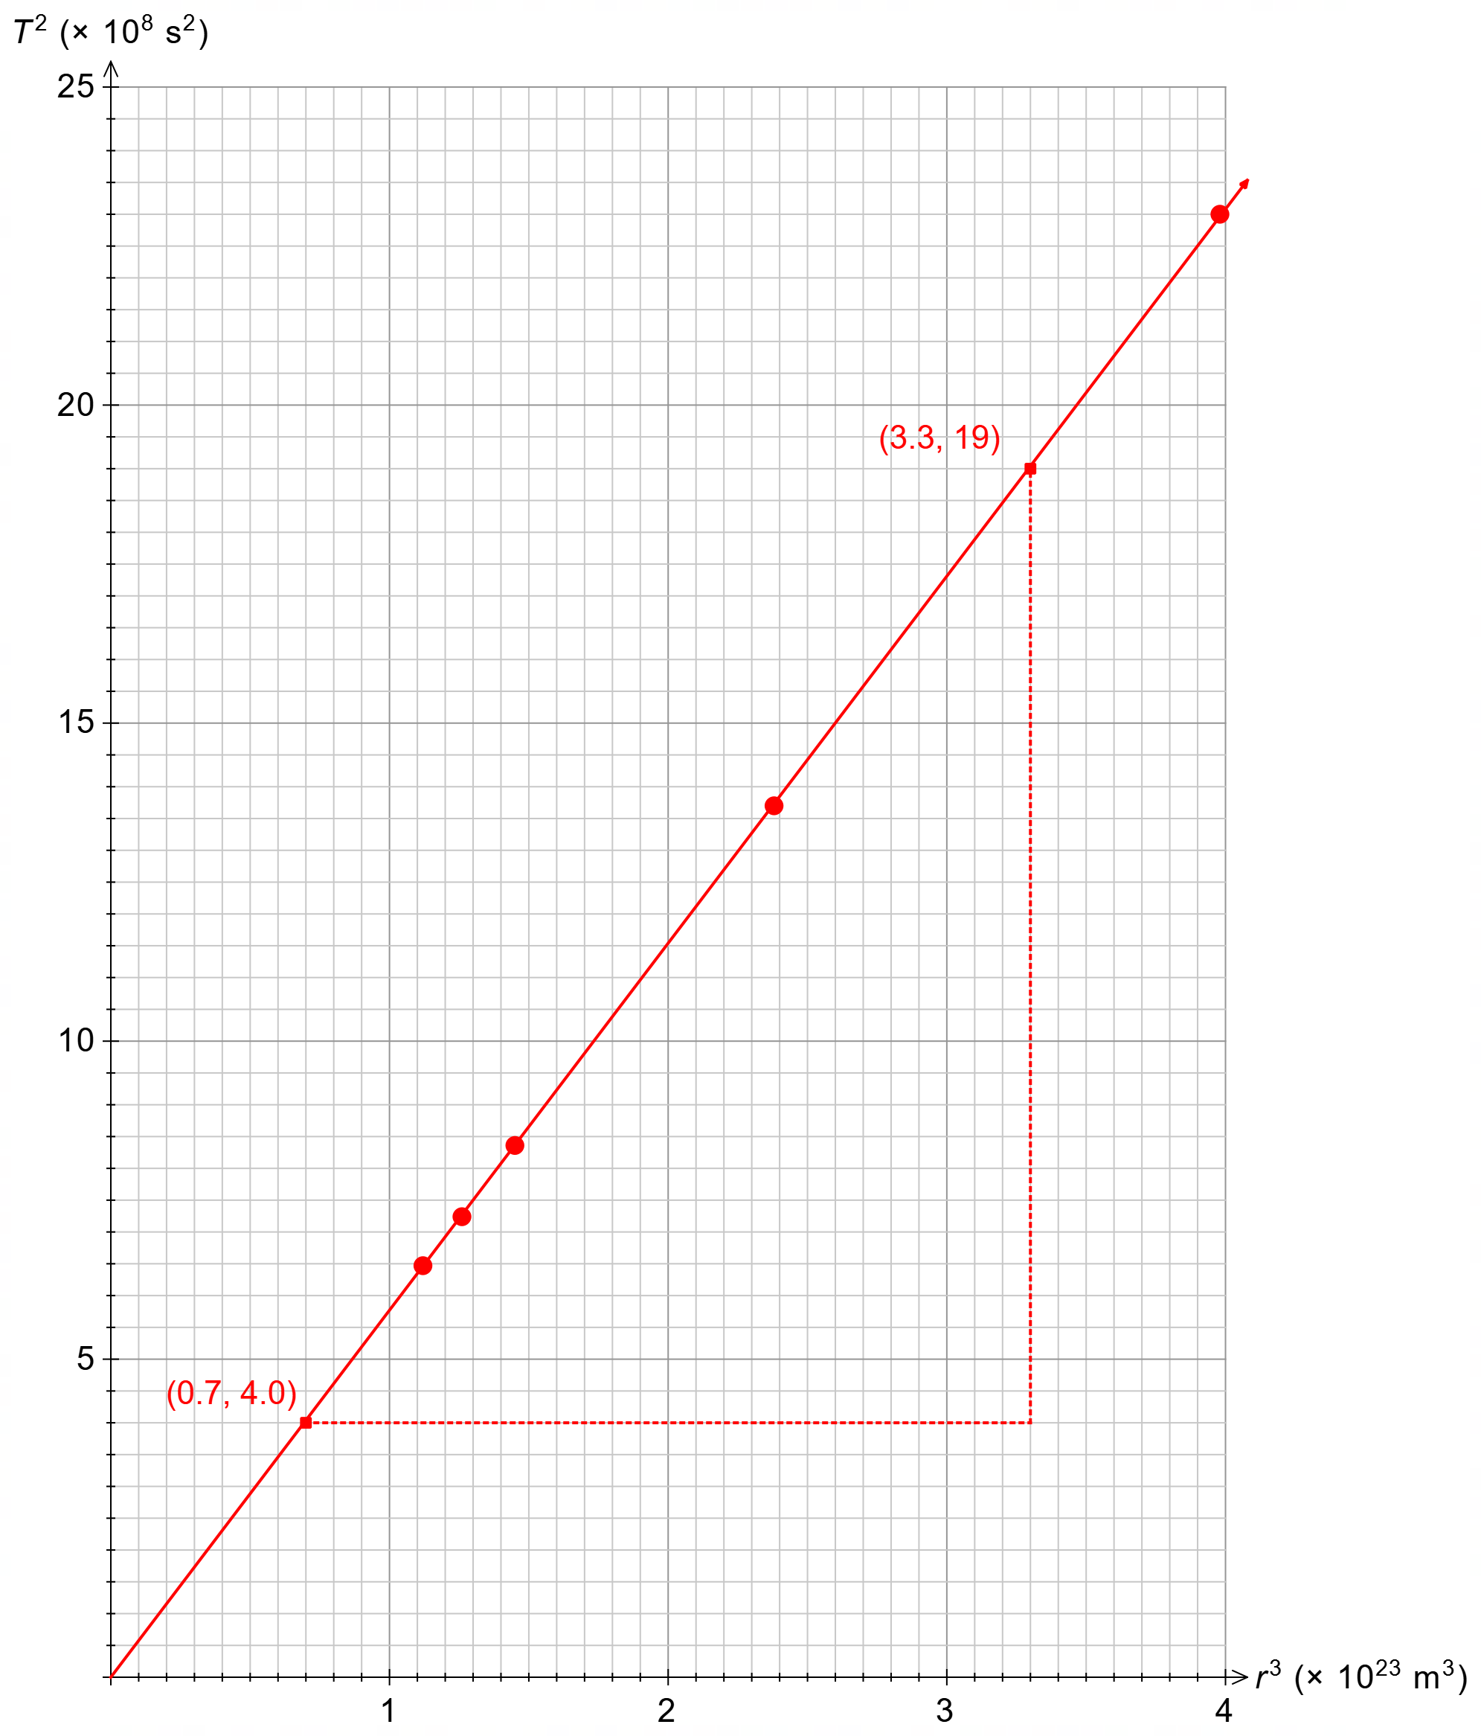

(c) Calculate the gradient of the line of best fit. Indicate on the graph the coordinates of the points used to calculate the gradient. Include units in your answer. (4 marks)

Element | Description | Marks
Coordinates marked on graph or construction lines shown | $$(0.7, 4.0) and (3.3, 19)$$ | 1
Calculates gradient including axis scale factors | $$m=\frac{(19-4.0)×{10}^{8}}{(3.3-0.7)×{10}^{23}}$$ | 1
Calculates gradient | $$m=5.8×{10}^{-15}$$  $$(allow 5.6-6.0×{10}^{-15})$$ | 1
Indicates units | $$Units=s^{2}.m^{-3}$$ | 1
 | Total | 4

(d) Use your answer to part (c) to calculate the mass of Neptune, giving your answer to two significant figures. (4 marks)

Element | Description | Marks
Rearranges Kepler’s 3rd law for mass of Neptune including gradient | $$gradient, m=\frac{4π^{2}}{GM}$$  $$M=\frac{4π^{2}}{G×m}$$ | 1
substitutes the gradient calculated and the gravitational constant | $$M=\frac{4π^{2}}{6.67×{10}^{-11}×5.77×{10}^{-15}}$$ | 1
Calculates the mass of Neptune | $$M=1.03×{10}^{26} kg$$  $$(allow 0.99→1.06×{10}^{26})$$ | 1
Expresses answer to 2 SF. | $$M=1.0×{10}^{26} kg$$  $$(or 1.1×{10}^{26} kg)$$ | 1
 | Total | 4

Question 16 (8 marks)

(a) By finding the height of the ball as it passes between the goal posts, determine if a goal is scored. (4 marks)

Element | Description | Marks
determines initial horizontal and vertical velocities | $$u_{x}=20.0×\cos{40.0°}=15.3 m/s$$  $$u_{y}=20.0×\sin{40.0°}=12.9 m/s$$ | 1
uses horizontal range and speed to determine time | $$t=\frac{s_{x}}{u_{x}}=\frac{34.0}{15.3}=2.22 s$$ | 1
substitutes vertical velocity and time into vertical displacement formula | $$s=u_{y}.t+\frac{1}{2}at^{2}$$  $$s=12.9×2.22+\frac{1}{2}×(-9.8)×{\left(2.22\right)}^{2}$$ | 1
calculates vertical displacement to show that $s>3.00 m$ | $$s=4.40 m >3.00 m$$ | 1
 | Total | 4

(b) Determine the speed of the rugby ball as it passes over the horizontal crossbar. (4 marks)

Element | Description | Marks
uses equation of motion to find vertical speed at $t=2.22 s$ | $$v_{y}^{2}=u_{y}^{2}+2as$$  $$v_{y}^{2}={\left(12.9\right)}^{2}+2×(-9.8)(4.40)$$ | 1
calculates final vertical velocity | $$v_{y}=8.95 m/s (down)$$ | 1
uses calculated components to find final speed of ball | $$v=\sqrt{v_{y}^{2}+v_{x}^{2}}$$  $$=\sqrt{{8.95}^{2}+{15.3}^{2}}$$ | 1
calculates correct final speed | $$v=17.7 m/s$$ | 1
 | Total | 4

Question 17 (15 marks)

(a) Show that the tension in the chain is approximately 5000 N. (5 marks)

Element | Description | Marks
Uses the concept of rotational equilibrium and sums torques about the pivot to zero | $$Στ=T_{⊥}.r_{1}-W_{d}.r_{2}-W_{b}.r_{3}=0$$ | 1
substitutes correct radial arm lengths and uses $\sin{53.0°}$ for tension and $\sin{67.0°}$ for weight components of the drawbridge and boards | $$Στ=\left(T\sin{53.0°}\right)×4.00$$  $$-\left(482×9.8×\sin{67.0°}\right)×3.00$$  $$-\left(68.0×9.8×\sin{67.0°}\right)×5.00=0$$ | 1 – 2
Rearranges and simplifies | $$3.195 T-13044-3067=0$$  $$3.195 T=16111$$ | 1
Solves for tension | $$T=5043=5.04×{10}^{3} N$$ | 1
 | Total | 5

(b) Determine the magnitude of the reaction force acting at the pivot on the drawbridge.
(5 marks)

Element | Description | Marks
Sums vertical forces including bridge and boards, sums to zero and substitutes tension and weight force, to find $R_{y}$ | $$ΣF_{y}=T_{y}+R_{y}-\left(W_{d}+W_{b}\right)=0$$  $$ΣF_{y}=5043×\sin{30.0°}+R_{y}-5390=0$$ | 1
Calculates $R_{y}$ | $$R_{y}=2869 N$$ | 1
Sums horizontal forces and substitutes values of tension to find $R_{x}$ | $$ΣF_{x}=R_{x}-T_{x}=0$$  $$ΣF_{y}=R_{x}-5043×\cos{30.0°}=0$$ | 1
Calculates $R_{x}$ | $$R_{x}=4367 N$$ | 1
Uses Pythagoras to find $R$ | $$R=\sqrt{{4367}^{2}+{2869}^{2}}=5225=5.23×{10}^{3} N$$ | 1
 | Total | 5

(c) Due to the angle of the drawbridge, the boards start to slide down the drawbridge towards the pivot. Explain how the size of the reaction force at pivot initially changes? Circle your answer and give an explanation below. (5 marks)

Element | Description | Marks
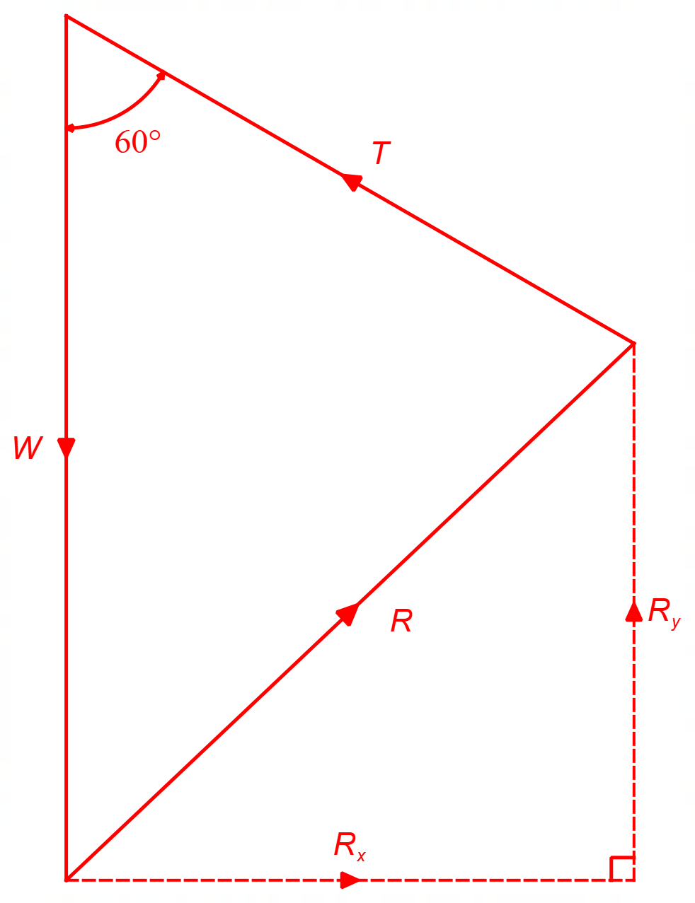
Reduced CW torque | Since the boards are closer to the pivot (reduced radial arm), the CW torque due to the boards decreases. | 1
Relates reduced CW torque to ACW torque and tension | Hence the ACW torque required is smaller and therefore the size of the tension force will be smaller (but same direction). | 1
Components of reaction force $R_{x}$ and $R_{y}$. | Thus, the horizontal component of the reaction force is decreased, and the vertical component of the reaction is increased. | 1
Compares changes in $R_{x}$ and $R_{y}$. | Since the angle of the tension is more horizontal than vertical, the decrease in the $R_{x}$ will have a larger effect on $R$ than the increase in $R_{y}$ of the reaction force. | 1
Indicates correct change in reaction force | Hence – DECREASE | 1
 | Total | 5

Question 18 (12 marks)

(a) On the diagram below, draw the shape of the resulting magnetic field surrounding the two wires, due to the currents travelling in the two wires. Use at least three (3) field lines to indicate the shape of the magnetic field. (3 marks)

Element | Description | Marks
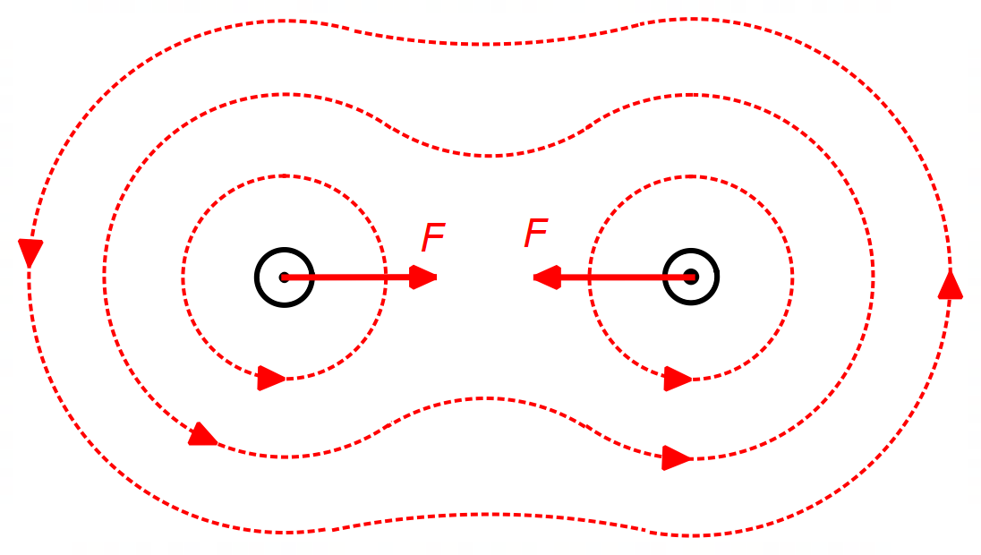
Correct direction | Magnetic field circles around wire 1 and wire 2 in an ACW direction | 1
Correct shape | Magnetic field looks a bit like a “saddle” shape as shown above, with low intensity magnetic field in between wire 1 and wire 2 | 1
Sufficient field lines | Drawn with at least three (3) field lines. | 1
 | Total | 3

(b) On the diagram in part (a) draw the force acting on each wire. (1 mark)

Element | Description | Marks
Indicates correct force direction | Indicates equal forces on each wire towards each other (attractive) | 1
 | Total | 1

(c) Calculate the magnitude of the magnetic field at the position of the person due ONLY to the current in wire 1. (3 marks)

Element | Description | Marks
Calculates distance from wire 1 to the person | $$r=\sqrt{{8.00}^{2}+{6.00}^{2}}=10.0 m$$ | 1
Uses formula for magnetic field near wire to determine magnetic field where $r=10.0 m$ and $μ_{0}=4π×{10}^{-7}$ | $$B=\frac{μ_{0}}{2π}\frac{I}{r}=\frac{4π×{10}^{-7}}{2π}×\frac{710}{10.0}$$ | 1
Calculates magnetic field strength | $$B=1.42×{10}^{-5} T$$ | 1
 | Total | 3

(d) Use your answer from part (c) to determine the magnitude and the direction of the total magnetic field measured by the person. If you were not able to calculate part (c) you may use a value of 1.5 × 10^{–5} T. (5 marks)

Element | Description | Marks
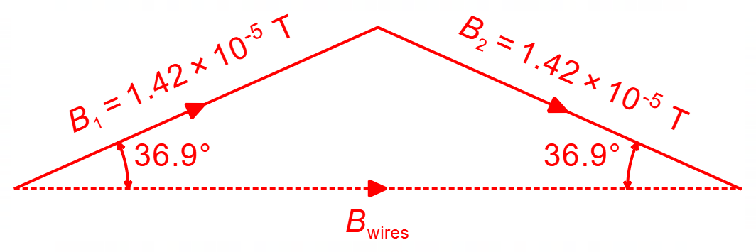
Determines correct angle of magnetic field in part (b) to horizontal | $$θ=\tan^{-1}\left(\frac{6}{8}\right)=36.9°$$ | 1
Uses correct trig ratio to find horizontal component. | $$B_{x}=1.42×{10}^{-5}×\cos{36.9°}=1.14×{10}^{-5} T$$ | 1
Includes component from both wires to calculate $B_{wires}$ (i.e. $×2$) | $$B_{wires}=2B_{x}$$  $$=2.27×{10}^{-5} T$$  ($2.40×{10}^{-5} T)$ | 1
Subtracts $B_{wires}$ from $B_{Earth}$ to get $ΣB$(recognises that $B_{wires}$ is south) | $$ΣB=B_{Earth}-B_{wires}$$  $$=4.20×{10}^{-5}-2.27×{10}^{-5}$$  $$=1.93×{10}^{-5} T$$  ($1.80×{10}^{-5} T$) | 1
Indicates direction consistent with answer in previous mark | $$North$$ | 1
 | Total | 5

Question 19 (11 marks)

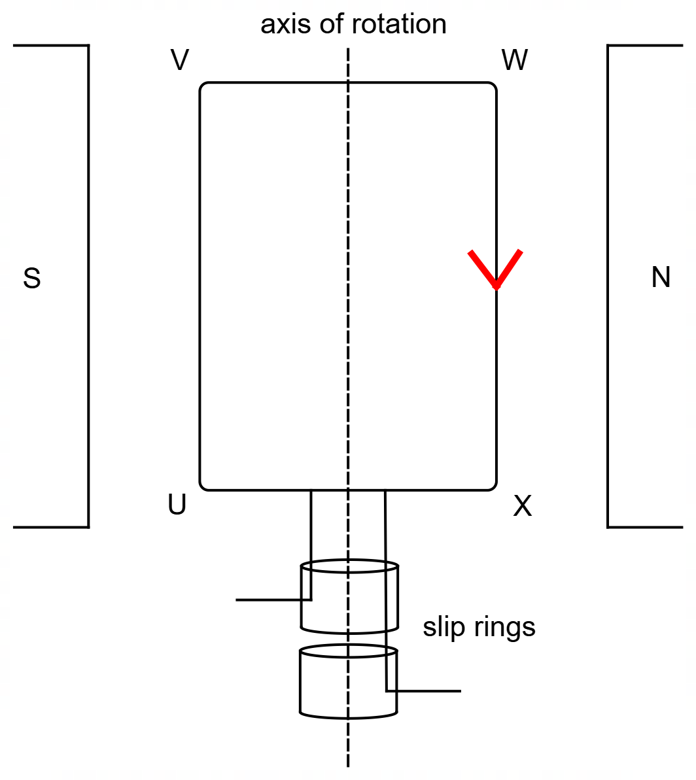

(a) At the instant shown in the diagram, side WX of the coil moves out of the page. On the diagram above indicate the direction of the induced current in the coil. (1 mark)

Element | Description | Marks
Indicates correct direction of current | Current down the page from W to X  (Clockwise in the coil) | 1
 | Total | 1

(b) Briefly outline the design and function of the “slip rings” in an AC generator. (2 marks)

Element | Description | Marks
Clearly explains design | The slip rings are continuous rings that each make electrical contact with one end of the coil. | 1
Clearly explains function | “Slip rings” are used to transmit the generated AC current from the coil to a connected circuit. | 1
 | Total | 2

(c) Calculate the flux threading the coil when the angle between the plane of the coil and the magnetic field makes an angle of 75.0°. (3 marks)

Element | Description | Marks
Uses the flux formula and angle $θ$ between $B$ and plane of coil (i.e., $\sin{θ}$) | $$∅=B.A.\sin{θ}$$ | 1
Substitutes angle, magnetic field, and area correctly | $$∅=0.636×(0.07×0.05)×\sin{75.0°}$$ | 1
Calculates correct flux | $$∅=2.15×{10}^{-3} Wb$$ | 1
 | Total | 3

(d) Determine the maximum EMF produced by this generator. (3 marks)

Element | Description | Marks
Uses peak EMF formula | $$ε_{peak}=2πNBAf$$ | 1
Substitutes correct values into formula | $$ε_{peak}=2π×28×0.636×(0.07×0.05)×24.0$$ | 1
Calculates correct EMF | $$ε_{peak}=9.40 V$$ | 1
 | Total | 3

(e) Besides the magnetic field and rate of rotation, state two modifications that could be made to this generator which would increase the output EMF. (2 marks)

Element | Description | Marks
Correct modification 1 | Increase the number of turns ($N$) | 1
Correct modification 2 | Increase the size (area) of the coil ($A$) | 1
 | Total | 2

Question 20 (18 marks)

Artificial Gravity in Space

(a) Derive the formula for the artificial gravity given in the text $g_{a}=4π^{2}rf^{2}$. (2 marks)

Element | Description | Marks
Uses the formula for velocity $v=2πrf$ and substitutes into $F_{c}$ | $$v=\frac{2πr}{T}=2πrf$$  $$a_{c}=\frac{v^{2}}{r}=\frac{{(2πrf)}^{2}}{r}$$ | 1
Simplifies expression | $$g_{a}=4π^{2}rf^{2}$$ | 1
 | Total | 2

(b) Using information from the text, determine the amount of artificial gravity experienced in the torus ring on Nautilus X. Express your answer to two significant figures, giving your answer in terms of “g”. (6 marks)

Element | Description | Marks
Extracts information from text for radius $r$ | $$r=\frac{12.2}{2}=6.10 m$$ | 1
Extracts information from the text for frequency $f$ | $$f=\frac{10}{60}=0.167 Hz$$ | 1
Substitutes values correctly and determines artificial gravity for Nautilus X | $$g_{N}=4π^{2}rf^{2}$$  $$g_{N}=4π^{2}\left(6.10\right){\left(0.167\right)}^{2}$$  $$g_{N}=6.69 m/s^{2}$$ | 1 – 2
Converts values of gravity to “g” | $$g_{N}=\frac{6.69}{9.8}=0.683 g$$ | 1
Expresses answer to max of 2 SF | $$g_{N}=0.68 g$$ | 1
 | Total | 6

(c) Given the information in the text and your answer to part (b), which of the two structures (Nautilus X or MTV) would be better for astronauts’ health and wellbeing? Briefly explain your answer. (2 marks)

Element | Description | Marks
Relevant information from text | “From a human perspective, rotation rates greater than 5 rpm tend to cause imbalance in the sensitive organs in our ears.” | 1
Correct answer | Since $f_{N}=10 rpm>5 rpm$, the MTV will be better for astronauts. | 1
 | Total | 2

(d) If the astronaut in Figure 2 is experiencing “0.8g”, indicate on Figure 2 the position(s) where the astronaut would experience “0.4g”. (1 mark)

Element | Description | Marks
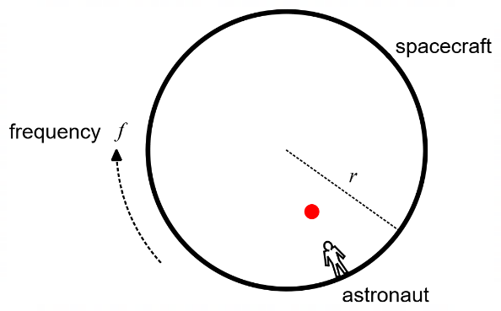
Accurately locates position | Position of “0.4g” should be halfway between centre and astronaut | 1
 | Total | 1

(e) Calculate the radius of the “very large structure” referred to in paragraph 3. (3 marks)

Element | Description | Marks
Extracts acceleration and frequency from text | $$g_{a}=9.8 m/s^{2} f=\frac{1}{60} Hz$$ | 1
Rearranges formula for radius $r$ as subject and substitutes values | $$r=\frac{g_{a}}{4π^{2}f^{2}}=\frac{9.8}{4π^{2}{\left(\frac{1}{60}\right)}^{2}}$$ | 1
Calculates correct radius | $$r=894 m$$ | 1
 | Total | 3

(f) State and explain two differences between the artificial gravity that would be experienced on the MTV (or Nautilus X) and gravity that is experienced on Earth. (4 marks)

Element | Description | Marks
Lists Difference 1 | Artificial gravity varies significantly with distance | 1
Correct Explanation | The radius of the Earth is >> than the radius of a spacecraft, hence the variation of the centripetal force in a spacecraft is much greater than the variation of the earth’s gravity due to a change in distance from earth’s centre. | 1
Lists Difference 2 | Gravity on Earth pulls down, whereas the artificial gravity on a spacecraft pushes “up”. | 1
Correct Explanation | On Earth, the normal force is a reaction force to our weight force.  On a spacecraft the centripetal force (gravity) is a reaction to the inertial force (equal and opposite). | 1
Other Possible Difference | $F_{g}$ on earth doesn’t require contact, whereas simulated gravity in space does require contact.
 | Total | 4

Question 21 (18 marks)

Millikan’s Oil Drop Experiment

(a) Complete the last column in Table 1 by determining the missing values. Write the values in the table. (2 marks)

Element | Description | Marks
First missing entry | $$1.55$$ | 1
Second missing entry | $$1.57$$ | 1
 | Total | 2

(b) On Figure 4 indicate the direction of the electric field by placing arrows on the field lines in the diagram. (1 mark)

Element | Description | Marks
Correct direction of field | Arrows on the field lines should be DOWN | 1
 | Total | 1

(c) In both scenarios in Figure 5, Millikan measured the velocities when the droplets were moving with constant speed. Explain the significance of this constant speed in relation to the forces acting on the droplets and how this helped Millikan with his experiment. (3 marks)

Element | Description | Marks
Relates constant speed to acceleration | When the oil droplet moves with constant speed, it has zero acceleration | 1
Relates acceleration to force | Hence, the sum of the forces $ΣF=0$ | 1
Relates weight force to drag force(s) and electric force | This allowed Millikan to be able to find the weight forces of the very small oil droplets. | 1
 | Total | 3

(d) Write an equation for the drag forces in terms of the other forces acting on the oil droplets when the voltage is turned on ($D_{down}$) and when the voltage is turned off ($D_{up}$). (2 marks)

Element | Description | Marks
Correct force equation when Voltage Turned On | $$D_{down}=F_{E}-W$$ | 1
Correct force equation when Voltage Turned Off | $$D_{up}=W$$ | 1
 | Total | 2

(e) An important factor in this experiment is the value of gravity. In Chicago, where Millikan did the original experiment, $g=9.802$ m s^{–2}. Suppose that the original experiment had been done in a location where the value of gravity was much lower than in Chicago. How would the velocities of the oil droplets ($v_{up}$ and $v_{down}$) change? Explain. (4 marks)

Element | Description | Marks
Relates gravity to weight | If $g$ is lower, then $W$ is smaller. | 1
Relates drag force to velocity | An increased drag forces implies an increased velocity (from text, para 5) | 1
Relates weight to drag force and $v_{up}$ when voltage is on. | When $W$ is lower, drag force $D_{down}$ is higher (since $D_{down}=F_{E}-W$) meaning that $v_{up}$ is increased.  OR,  Answer consistent with equation in part (d) | 1
Relates weight to drag force and $v_{down}$ when voltage is off. | When $W$ is lower, drag force $D_{up}$ is lower (since $D_{up}=W$) meaning that $v_{down}$ is decreased.  OR,  Answer consistent with equation in part (d) | 1
 | Total | 4

(f) Using the information given in the text and in Table 1, calculate the electric field strength acting on Droplet # 6. (2 marks)

Element | Description | Marks
Uses correct formula and values of distance $d$ from text and voltage $V$ from Table 1 | $$E=\frac{V}{d}=\frac{1760}{0.0160}$$ | 1
Calculates correct electric field strength $E$ | $$E=1.10×{10}^{5} N/C$$ | 1
 | Total | 2

(g) Using the information in the column ‘Charge Difference’, determine an experimental value for the elementary charge of an electron. If you could not determine the values for part (a), you can still use the incomplete information in the last column. (4 marks)

Element | Description | Marks
Determines the total number of electrons | Using the smallest charge, it can be inferred the number of electrons in the ‘charge difference’ is:  $$n=10$$  $$(n=8)$$ | 1
Calculates the total charge of ‘Charge Differences’ | $$\left(4.65+1.55+1.59+6.41+1.57\right)×{10}^{-19}=15.77×{10}^{-19}C$$ | 1
Divides total charge by total number of electrons | $$q_{e}=\frac{15.77×{10}^{-19} C}{10}$$ | 1
Calculates average charge for ‘elementary charge’ | $$q_{e}=1.58×{10}^{-19} C$$  $$(q_{e}=1.58×{10}^{-19} C)$$ | 1
 | Total | 4

OR

Element | Description | Marks
Determines number of elementary charges on each oil droplet from table | $$n=3, 1, 1, 4, 1$$ | 1
Determines the elementary charge on each oil droplet by dividing by each charge by $n$ | $$\frac{4.65}{3}=1.55, \frac{1.55}{1}=1.55, \frac{1.59}{1}=1.59$$  $$\frac{6.41}{4}=1.6025, \frac{1.57}{1}=1.57$$ | 1 – 2
Calculates average charge for ‘elementary charge’ | $$\frac{1.55+1.55+1.59+1.6025+1.57}{5}=1.57$$  $$q_{e}=1.57×{10}^{-19} C$$ | 1
 | Total | 4

End of Questions

